**LOCAL FUNDRAISER   
$10 from every seat sold for this event will be donated to Horizons Unlimited Child and Adult Care Food Program**

 PAINTING IT FORWARD

[](https://studio.pinotspalette.com/appleton/images/honey%20im%20home.jpg)

# **Falling Blossoms**

**Tuesday, September 17**

**7:00-9:00pm**

[226 East College Avenue, Appleton, WI](https://maps.google.com/maps?q=226%2BEast%2BCollege%2BAvenue%2C%2BAppleton%2C%2BWI%2B54911)

$35.00 *per painter*

**To register go to:** [[https://www.pinotspalette.com/appleton/event/352345](https://www.pinotspalette.com/appleton/event/315417)](https://www.pinotspalette.com/appleton/event/352345)

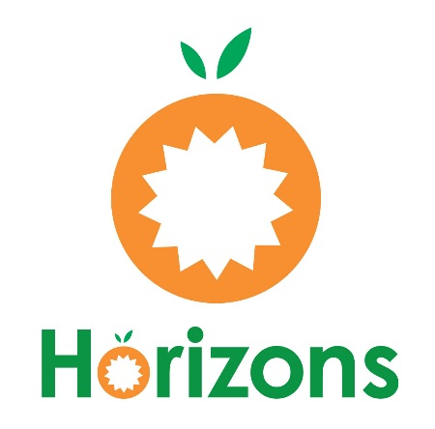

Thank you for supporting child nutrition and Horizons Unlimited Child and Adult Care Food Program!

www. horizonsfoodprogram.org

920-462-4805

horizonsfoodprogram1991@gmail.com